SQL ASSESMENT
Theme: Personal Expense Tracker DB
Section A: Concept Application
1.Explain how relational databases help maintain accuracy in expense records.
Relational databases maintain accuracy in expense records by organizing data into related tables such as users, categories, and expenses.
They use primary keys to uniquely identify each record
They use foreign keys to ensure valid relationships (e.g., every expense must belong to an existing user and category)
They reduce data redundancy by storing data in separate tables
They enforce constraints (like NOT NULL, UNIQUE) to prevent invalid data entry
They support transactions (COMMIT, ROLLBACK) to ensure correct and consistent updates
2. Why are constraints important in personal finance data?
Constraints are important in personal finance data because they ensure that the data stored in the database is valid, accurate, and reliable.
They prevent invalid entries (e.g., negative expense amount using CHECK constraint)
They ensure uniqueness (e.g., no duplicate user IDs using PRIMARY KEY)
They maintain valid relationships (e.g., expenses must belong to existing users using FOREIGN KEY)
They avoid missing data (e.g., NOT NULL ensures required fields are filled)
3. How does GROUP BY help analyze spending patterns?
GROUP BY helps analyze spending patterns by organizing data into groups based on a specific column, such as user or category.
It allows you to summarize data using functions like SUM(), AVG(), COUNT()
You can find total spending per category (e.g., Food, Rent)
You can analyze user-wise expenses to see who spends more
It helps in identifying trends and patterns in expenses
4. Explain a scenario where rollback is required during expense entry
A rollback is required when an error occurs during expense entry and the changes should not be saved.
Scenario:
A user enters a new expense of ₹500 for “Food”, but due to a mistake, the amount is entered as ₹50,000 or the wrong category is selected. While saving, the system detects the error.
In this case:
The transaction is cancelled using ROLLBACK
All changes made during that transaction are undone
The database returns to its previous correct state
5. How do views help users track monthly expenses efficiently?
Views help users track monthly expenses efficiently by providing a predefined and simplified way to access data.
A view can store a query that filters expenses for a specific month
It shows only relevant data (e.g., monthly total, category-wise spending)
It hides complex joins and calculations, making data easy to understand
Users can quickly access updated results without writing queries again
This saves time and makes tracking expenses faster and more convenient
6. Why use triggers for automatic category or balance updates?
Triggers are used to perform automatic actions in the database when certain events occur (like INSERT, UPDATE, DELETE).
In personal finance systems:
When a new expense is added, a trigger can automatically update the user’s balance
It can also update category totals (e.g., total spent on Food)
Ensures real-time updates without manual intervention
Maintains data consistency and accuracy
This reduces errors and ensures that related data is always up-to-date

SECTION B- SQL Hands-On
1.DDL UNDERSTADING
Explain why foreign keys are used: Specifically, why must user_id in
the expenses table correspond to a real ID in the users table?
Foreign keys are used to maintain referential integrity between tables.
In this case, user_id in the expenses table must correspond to a real user_id in the users table because:
- It ensures that every expense is linked to a valid existing user
- It prevents inserting records for users who do not exist
- It maintains data consistency and accuracy in the database
- It enforces a logical relationship between users and expenses
Mention one issue that would occur if foreign keys were removed:
Describe the risk of "Orphaned Records" (e.g., an expense existing for a
user who has been deleted).
If foreign keys are removed, the database can contain orphaned records.
Orphaned Record means:
A record in one table refers to a non-existing record in another table.
In this case:
An expense may exist in the expenses table with a user_id
But that user_id no longer exists in the users table (user deleted)
This makes the expense record invalid and meaningless

2. DML Operations
Insert 5 users into the users table with unique names and emails.
INSERT INTO users (user_id, name, email, created_at) VALUES
(1, 'Amit Shah', 'amit@gmail.com', '2026-01-01'),
(2, 'Priya Mehta', 'priya@gmail.com', '2026-01-02'),
(3, 'Rahul Patel', 'rahul@gmail.com', '2026-01-03'),
(4, 'Sneha Jain', 'sneha@gmail.com', '2026-01-04'),
(5, 'Karan Verma', 'karan@gmail.com', '2026-01-05');
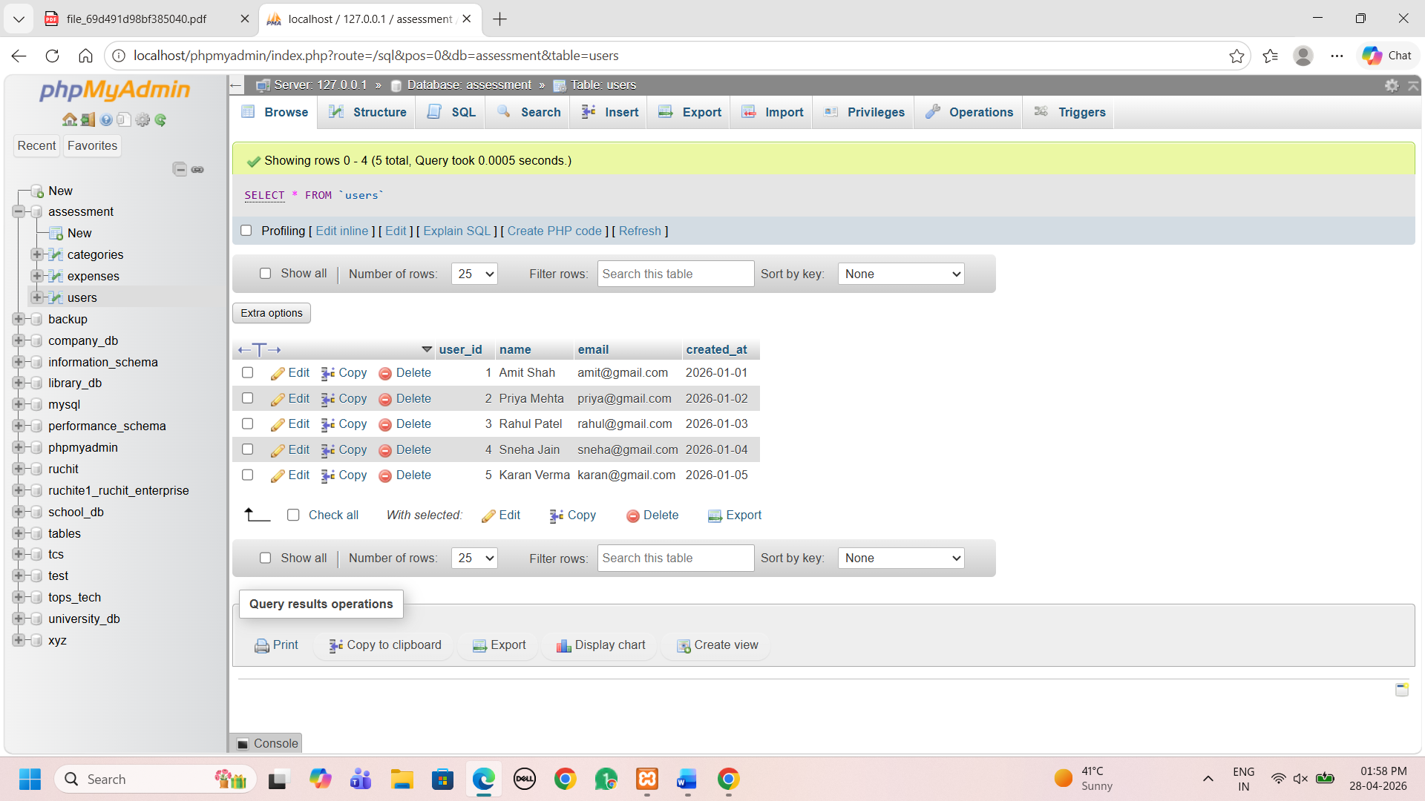

Insert 3 categories (e.g., 'Food', 'Rent', 'Entertainment').
INSERT INTO categories (category_id, category_name) VALUES
(1, 'Food'),
(2, 'Rent'),
(3, 'Entertainment');
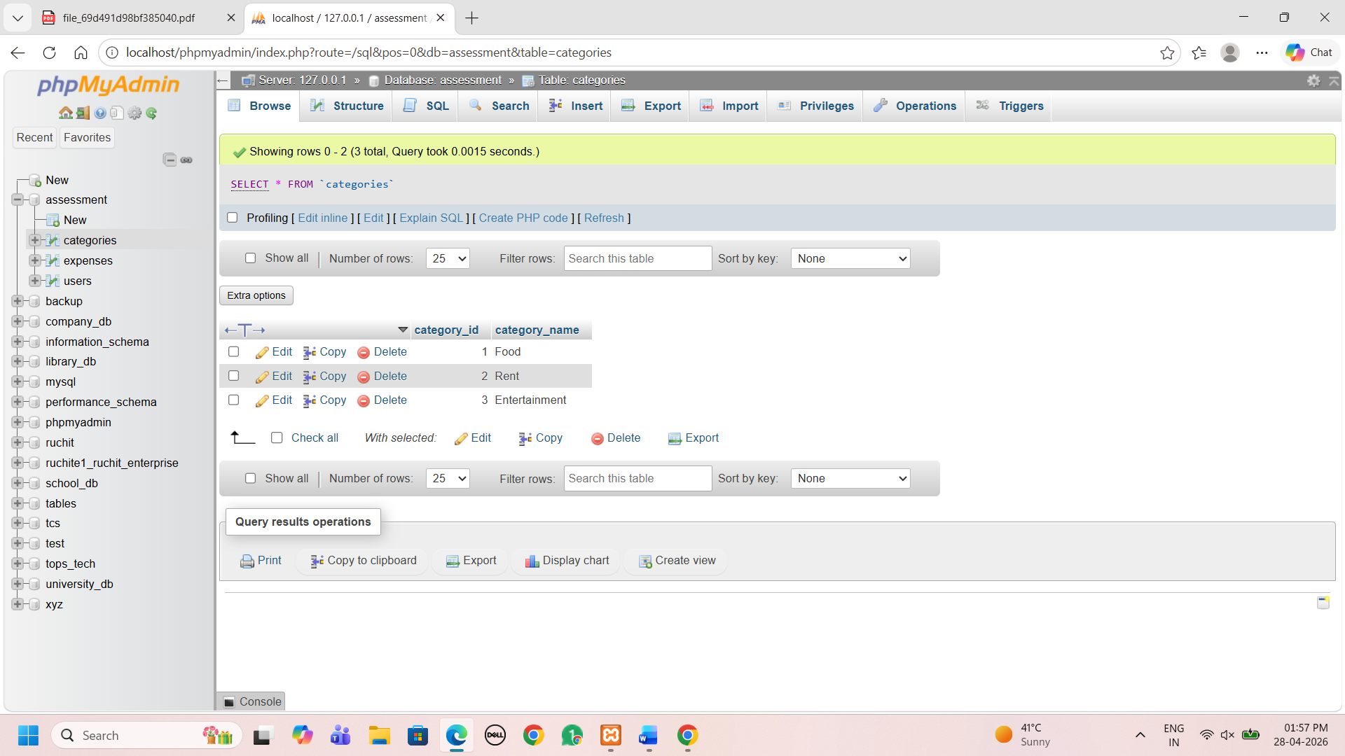
Insert 10 expense records distributed across different users and
Categories
INSERT INTO expenses (expense_id, user_id, category_id, amount, expense_date) VALUES
(1, 1, 1, 250.00, '2026-02-01'),
(2, 2, 2, 5000.00, '2026-02-02'),
(3, 3, 1, 300.00, '2026-02-03'),
(4, 4, 3, 700.00, '2026-02-04'),
(5, 5, 2, 4500.00, '2026-02-05'),
(6, 1, 3, 800.00, '2026-02-06'),
(7, 2, 1, 150.00, '2026-02-07'),
(8, 3, 2, 5200.00, '2026-02-08'),
(9, 4, 3, 900.00, '2026-02-09'),
(10, 5, 1, 200.00, '2026-02-10');
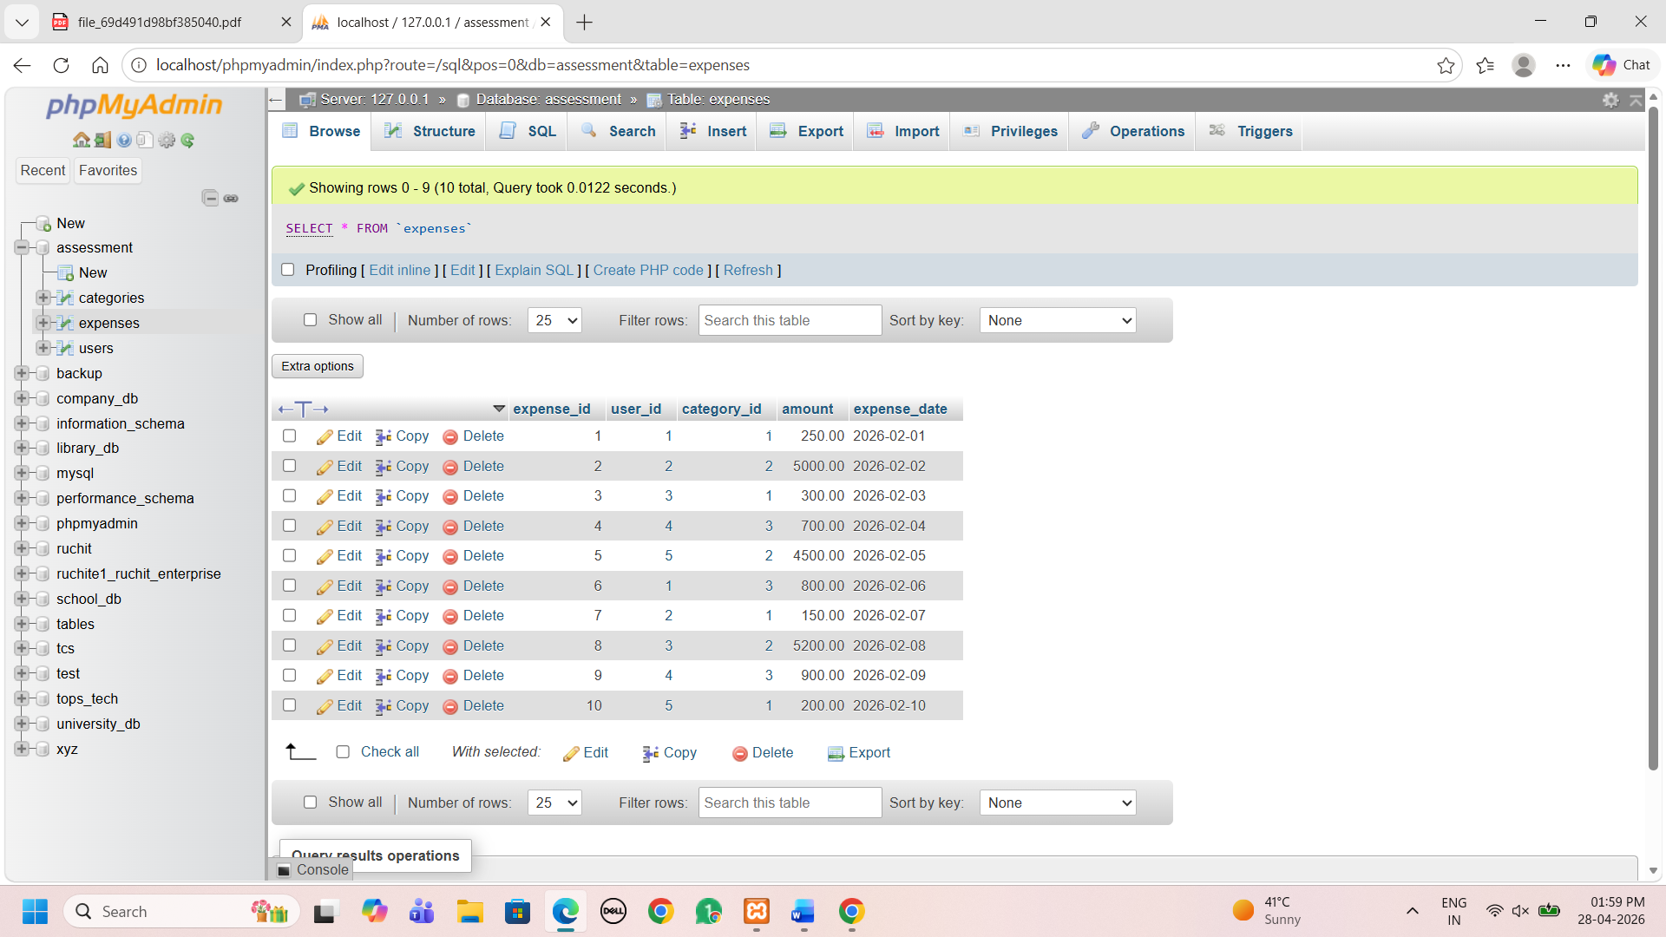
Update one incorrect expense: Use the UPDATE command to change
the amount of a specific expense_id.
UPDATE expenses
SET amount = 350.00
WHERE expense_id = 3;
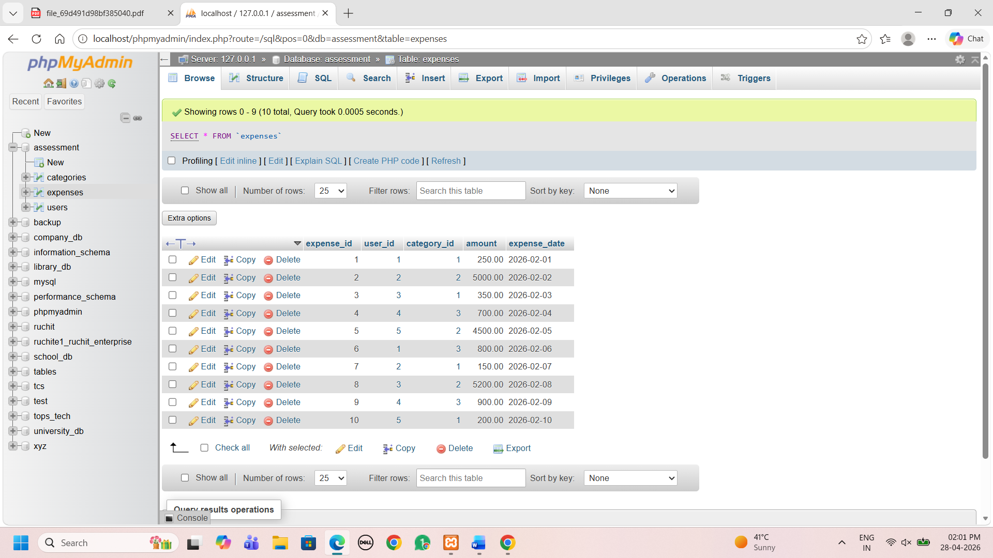

Delete one expense: Remove a record where the amount is less than a
specific value.
DELETE FROM expenses
WHERE amount < 200;
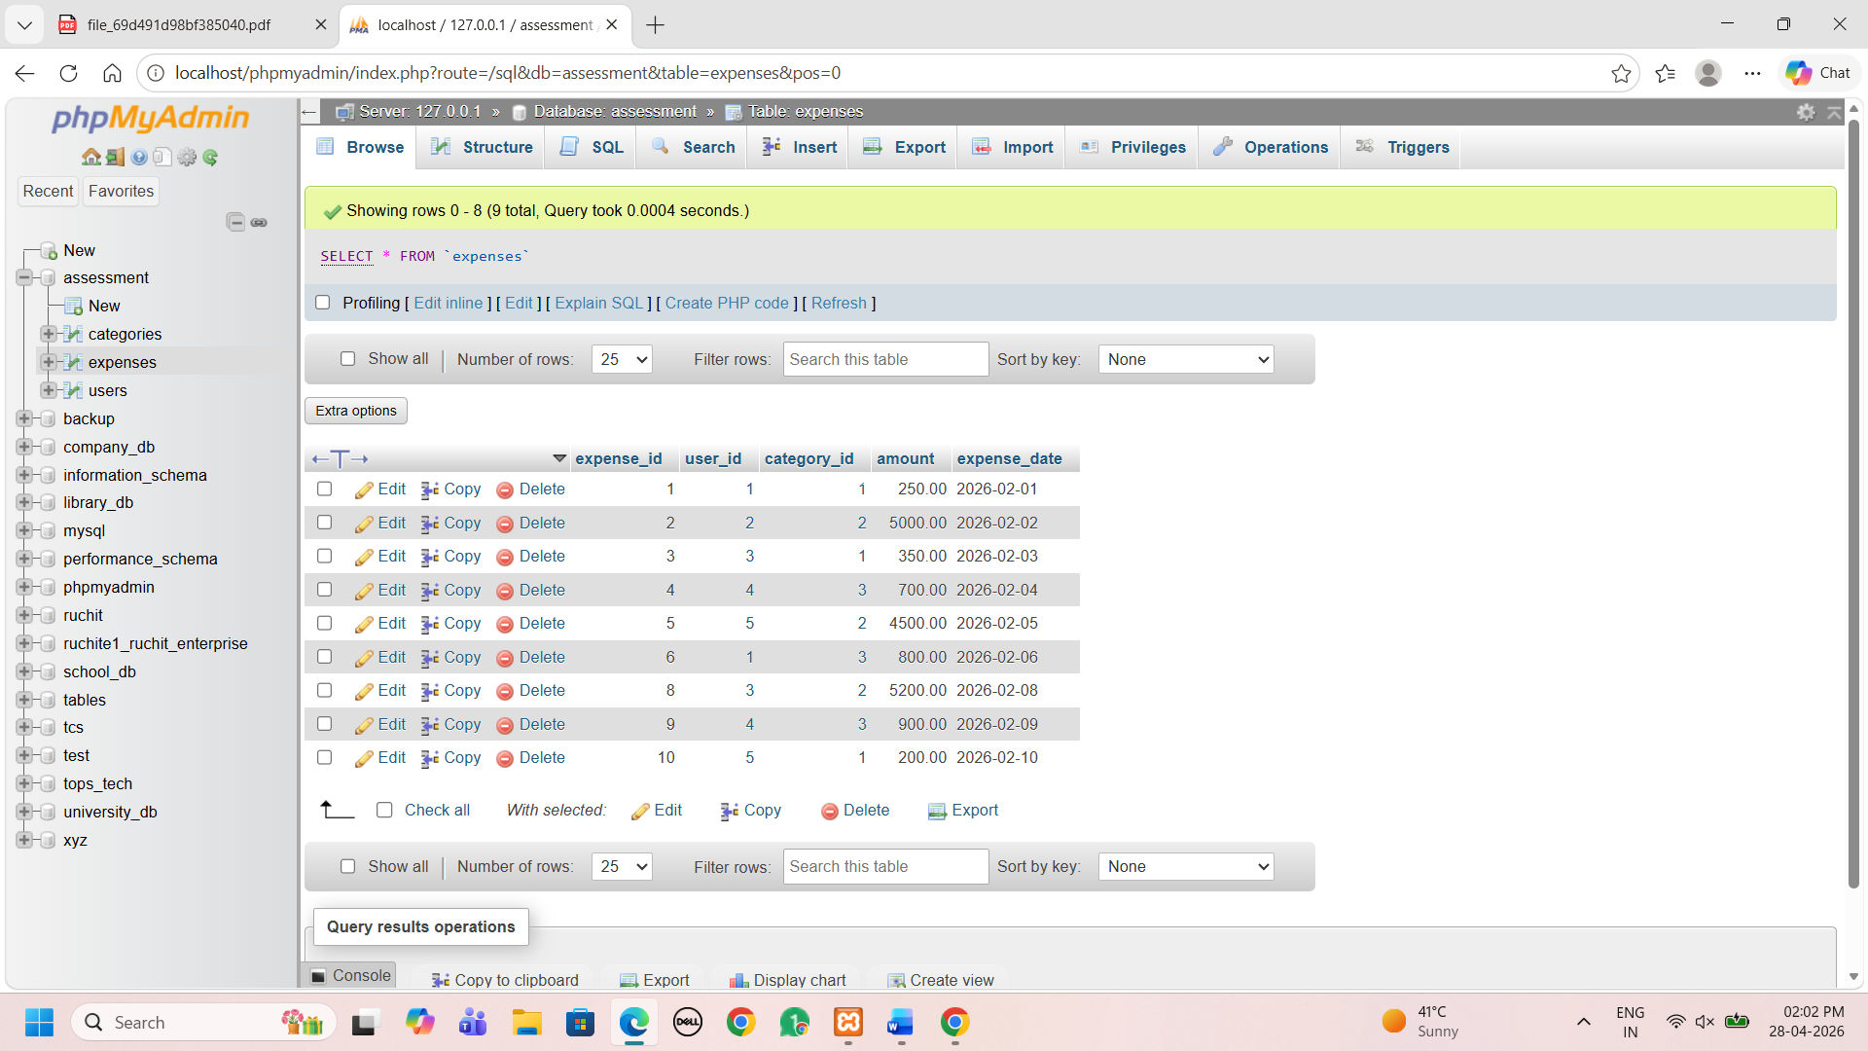
3. Data Retrieval
Display all expenses with details: Show the expense_date, amount,
name (from users), and category_name (from categories) using INNER
JOIN.
SELECT e.expense_date, e.amount, u.name, c.category_name
FROM expenses e
INNER JOIN users u ON e.user_id = u.user_id
INNER JOIN categories c ON e.category_id = c.category_id;
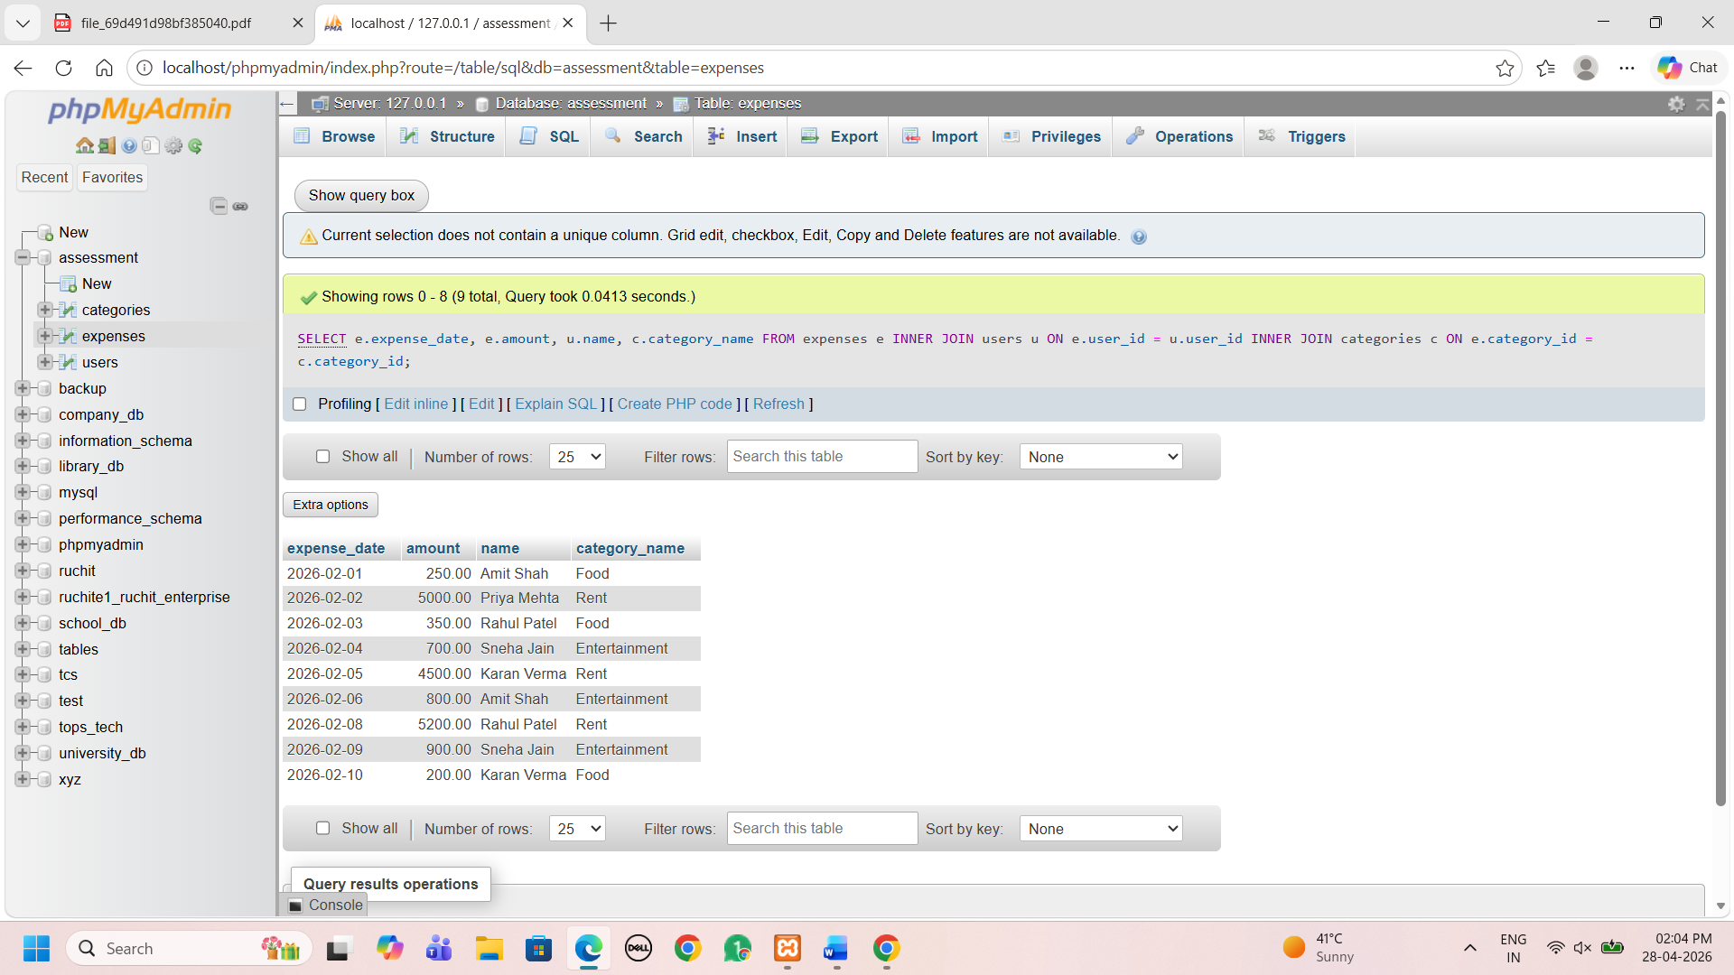
Show total expense amount per category: Use SUM(amount) and GROUP
BY category_name.
SELECT c.category_name, SUM(e.amount) AS total_amount
FROM expenses e
INNER JOIN categories c ON e.category_id = c.category_id
GROUP BY c.category_name;
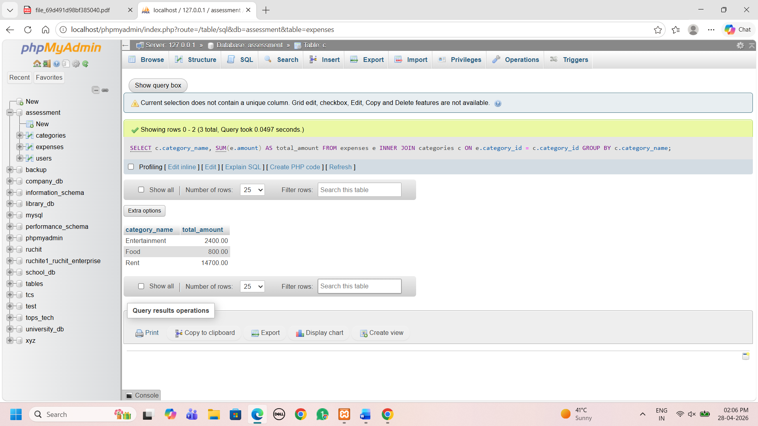
Display users sorted by total spending: List user names and their total
sum of expenses, ordered from highest to lowest.
SELECT u.name, SUM(e.amount) AS total_spending
FROM expenses e
INNER JOIN users u ON e.user_id = u.user_id
GROUP BY u.name
ORDER BY total_spending DESC;
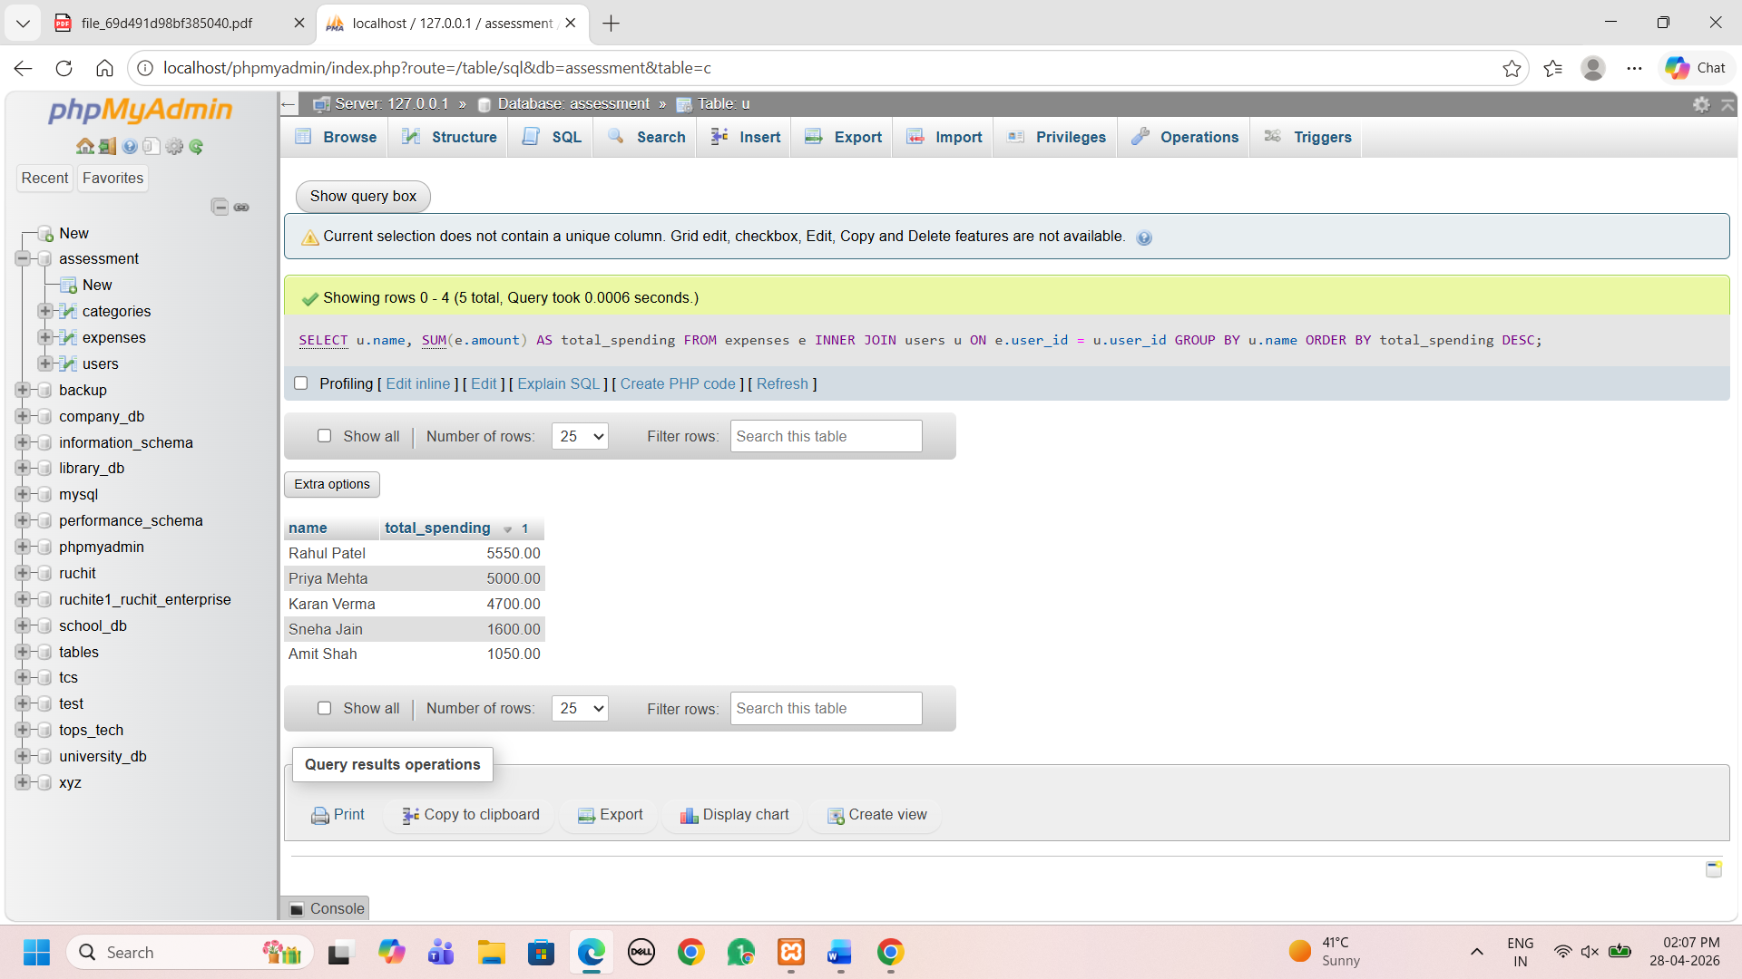
4. . Views
Create a view named ActiveUsersView: This view should list the name
and email of any user who has logged more than 5 individual expense
records.
CREATE VIEW ActiveUsersView AS
SELECT u.name, u.email
FROM users u
INNER JOIN expenses e ON u.user_id = e.user_id
GROUP BY u.user_id, u.name, u.email
HAVING COUNT(e.expense_id) > 5;
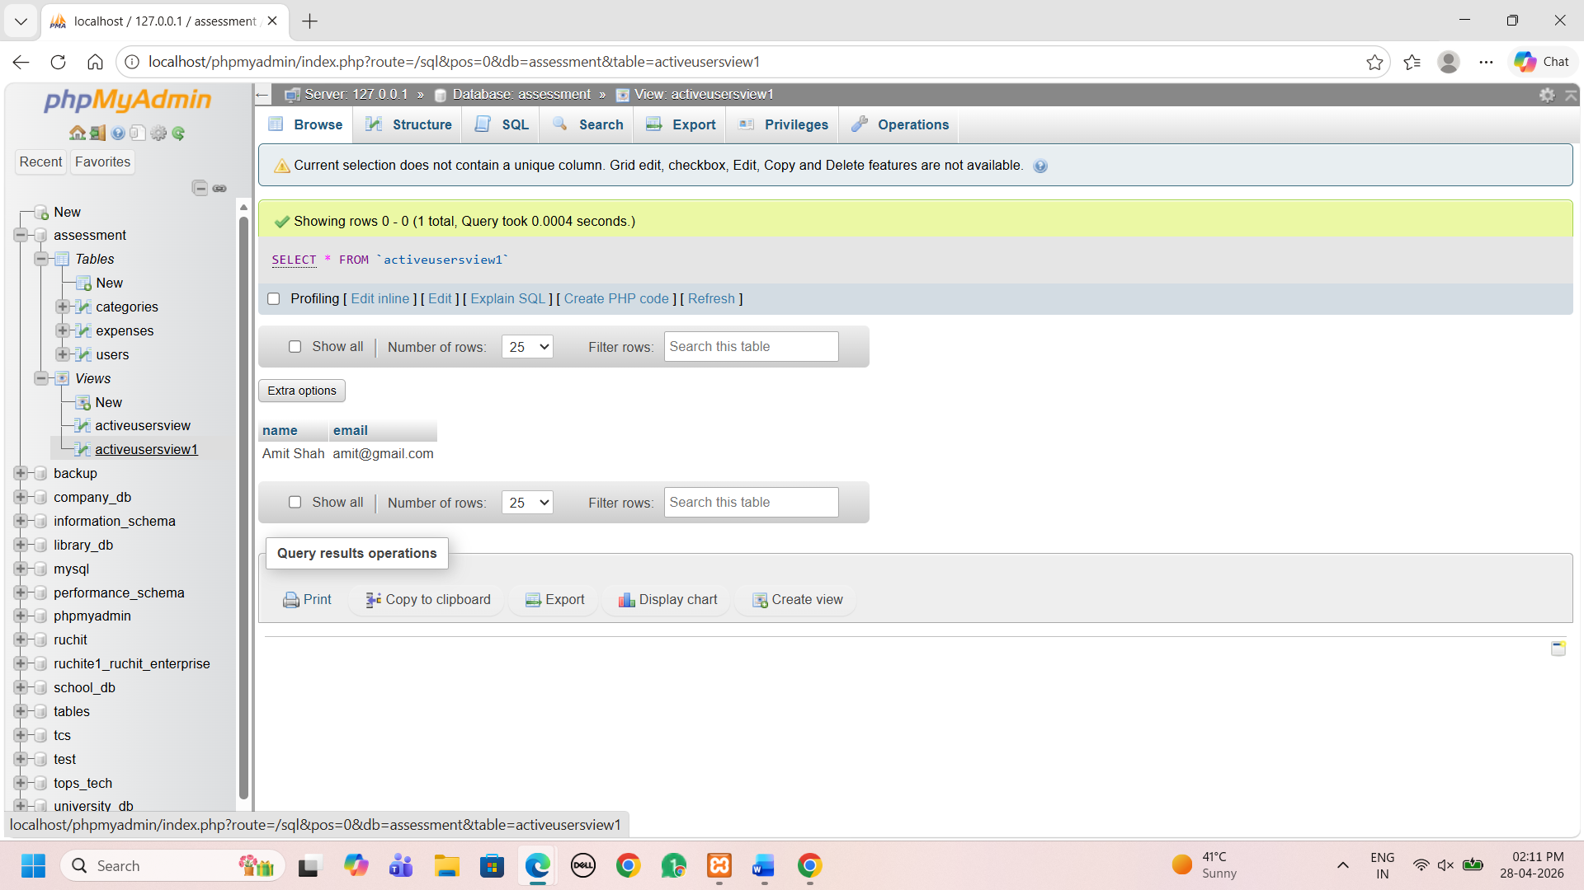
Query the view: Write a simple SELECT statement to show all data from
ActiveUsersView.
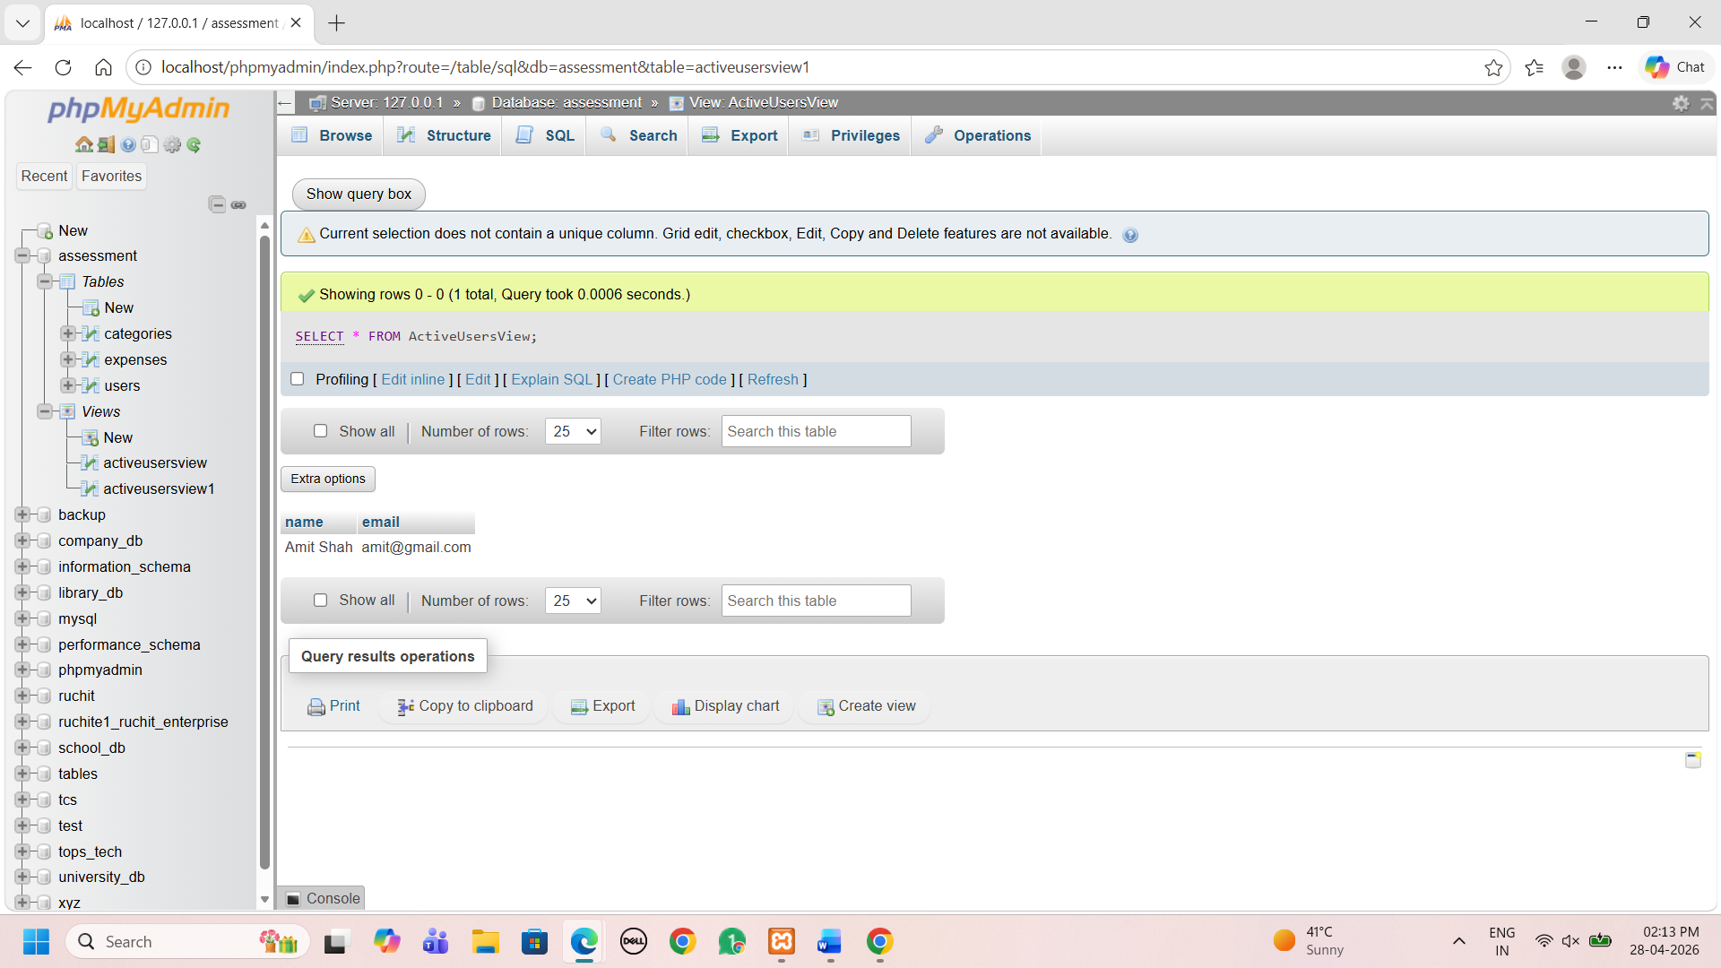
Section C: Mini Project
Mini Project: Expense Tracker DB
Using the same schema:
● Write CRUD queries
insert
INSERT INTO expenses (expense_id, user_id, category_id, amount, expense_date) VALUES (15, 2, 1, 300.00, '2026-03-01');
select
SELECT * FROM expenses;
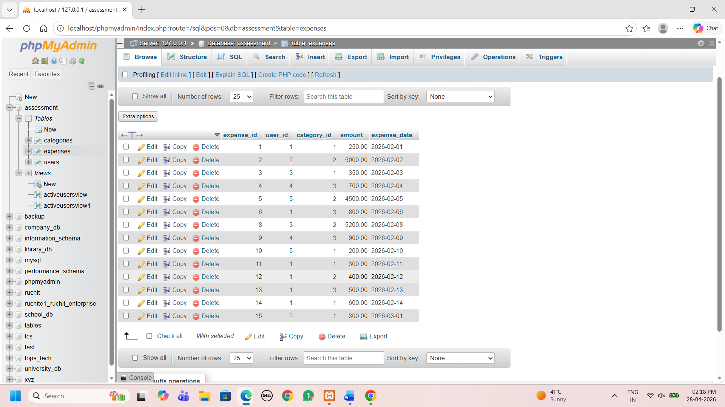
update
UPDATE expenses
SET amount = 500.00
WHERE expense_id = 15;
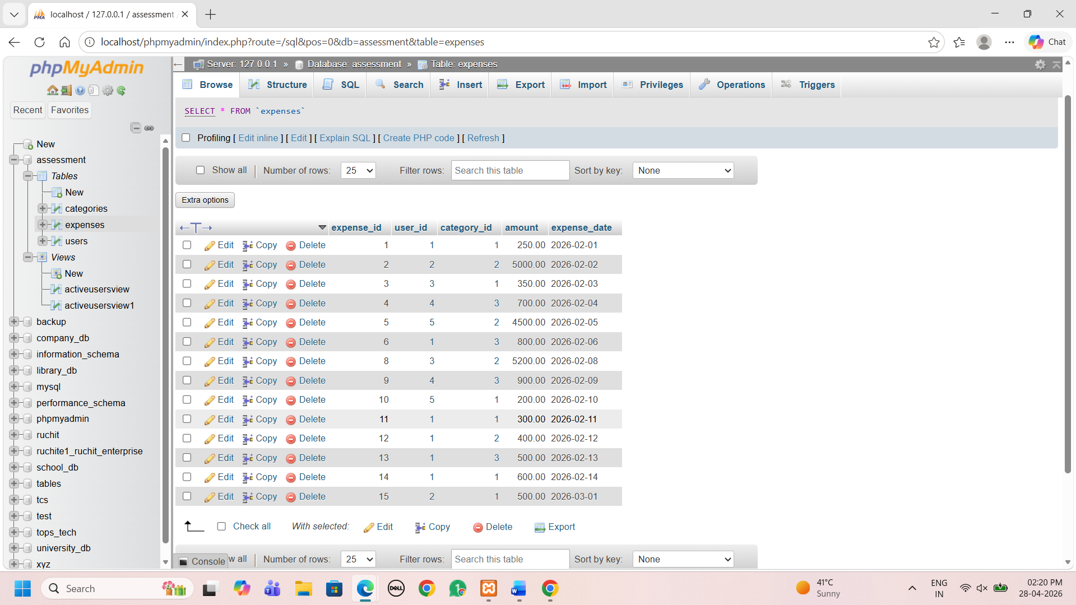
delete
DELETE FROM expenses
WHERE expense_id = 15;
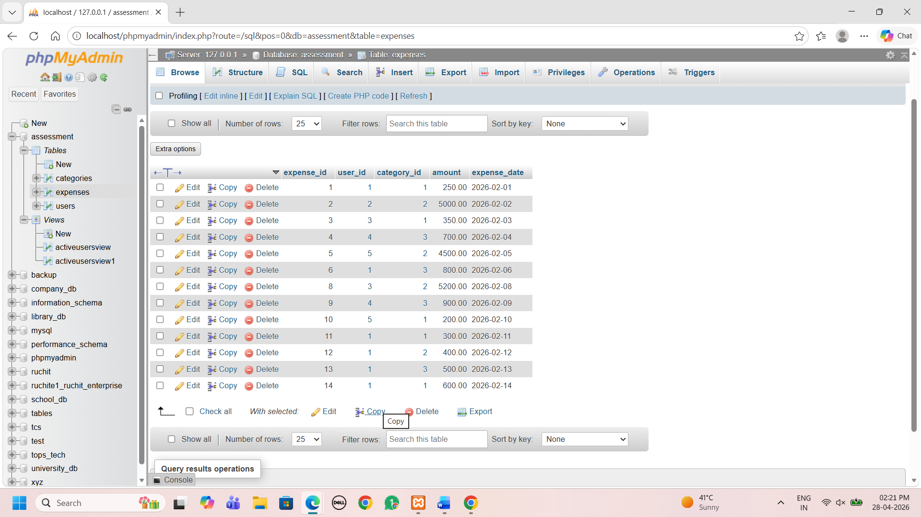

● Write a stored procedure to calculate monthly user expense
DELIMITER $$

CREATE PROCEDURE GetMonthlyExpense(
IN uid INT,
IN month_num INT,
IN year_num INT
)
BEGIN
SELECT u.name, SUM(e.amount) AS total_expense
FROM expenses e
INNER JOIN users u ON e.user_id = u.user_id
WHERE e.user_id = uid
AND MONTH(e.expense_date) = month_num
AND YEAR(e.expense_date) = year_num
GROUP BY u.name;
END $$

DELIMITER ;
CALLING
CALL GetMonthlyExpense(1, 2, 2026);
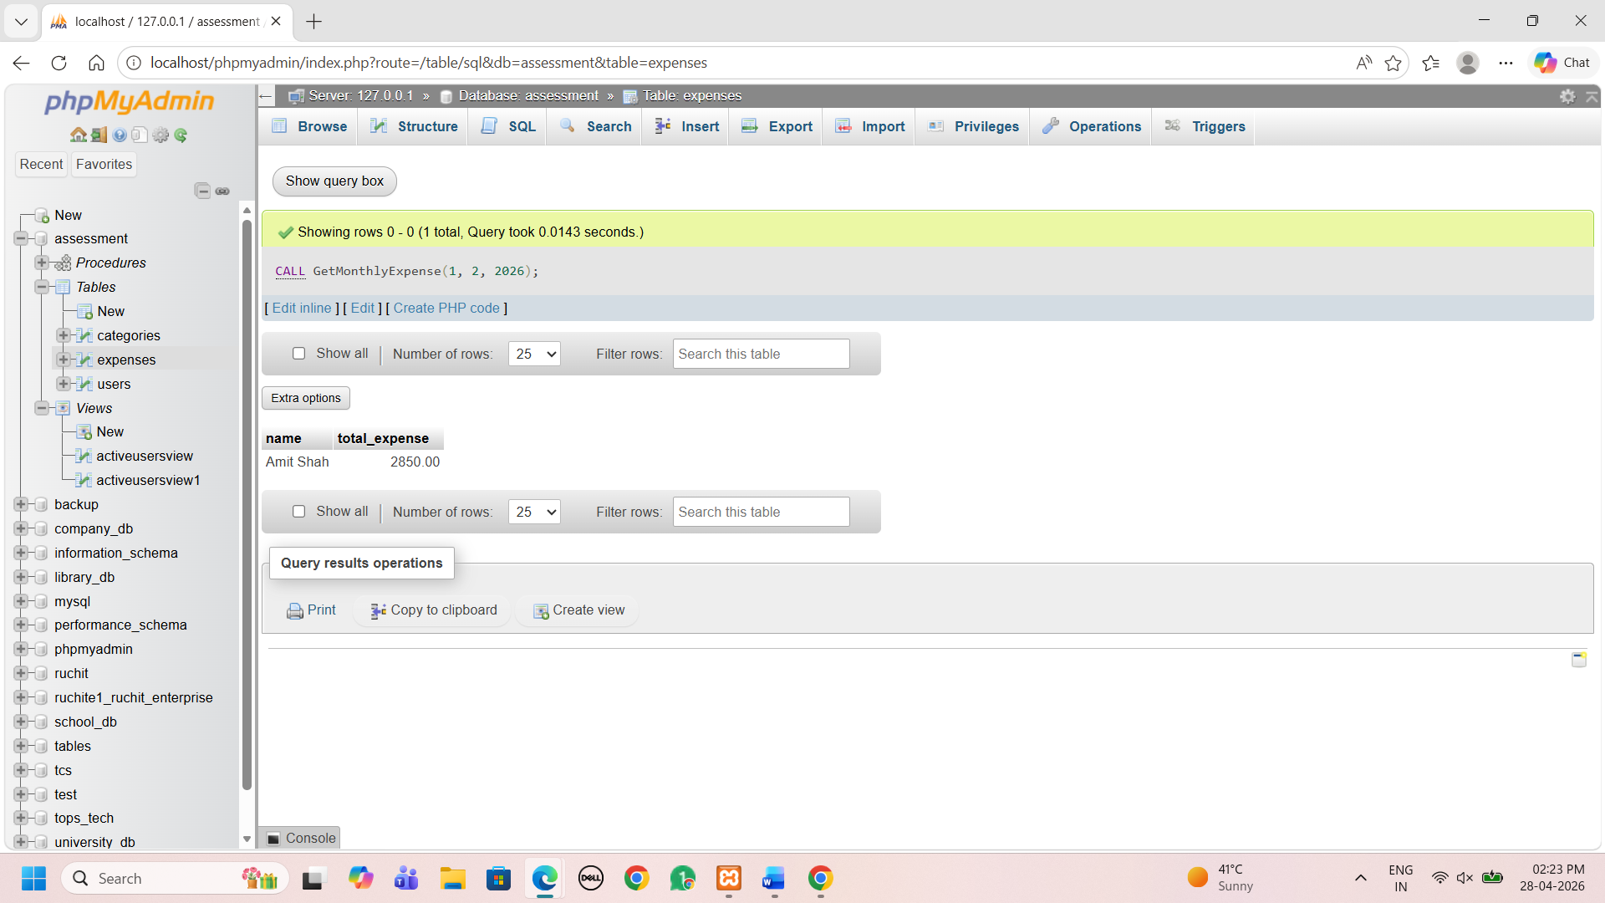
● Demonstrate COMMIT and ROLLBACK with example queries
START TRANSACTION;
-- Step 1: Insert new expense
INSERT INTO expenses VALUES (25, 1, 1, 1000, '2026-03-15');
-- Step 2: Update existing expense
UPDATE expenses
SET amount = 2000
WHERE expense_id = 1;
-- Step 3: Delete an expense
DELETE FROM expenses
WHERE expense_id = 3;
-- Save changes
COMMIT;
START TRANSACTION;
DELETE FROM expenses
WHERE expense_id = 4;
ROLLBACK;
